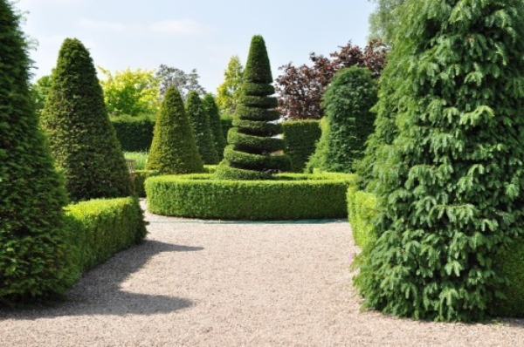
Nayeli Maciel-Salas
1 September 2026
I have chosen this image to replicate in my final project. While at first it might seem as though only one shape is used repeatedly, upon further and more detailed review, you can see that there are several different shapes being used. There will also have to be some layering to make the 3D scene look more like the original image.
The first 3D shape I would use is a cone for most of the trees. The cone would allow me to recreate the general shape of the tree while keeping the design simple. For the tree in the center of the image, with the bush-like shape around it, I would start with a torus for the surrounding bush. I would then use additional shapes to create the tree itself. To the left of the image, there is a rectangular-shaped bush, so I would use a box to recreate it. Lastly, I would use a plane as the floor for the garden. These basic shapes would give me a good starting point for recreating the major objects in the image.
The tree in the center of the image would need multiple shapes to make it more accurate. I would use a cone for the top portion of the tree and boxes for the rest of the tree, especially the parts that appear to spiral around the center. Using multiple shapes and layering them together would allow me to create a more detailed version of the tree instead of trying to make the entire object out of one shape.
I think the areas of the image I would choose to simplify would be the trees at the very back of the image. Since they are farther away, they do not need as much detail as the objects in the foreground. I could use simpler shapes for these trees without significantly changing the overall appearance of the scene. I also see an area where the tree and the rectangular bush could be combined into one prism. Combining these objects would simplify the scene while still keeping the general appearance of the original image.

